**COS10004: Computer Systems**

**Lab 7**

**Name: SWH00420 Tran Quoc Dung**

**Student ID: 103803891**

**16. Provide the lines of code from your lab07_GPIO18.ASM file that achieve the following:**

16.1. Establish the base address of the GPIO registers:

BASE = $3F000000

GPIO_OFFSET = $200000

move r0, BASE

orr r0, GPIO_OFFSET

16.2. Program GPIO18 for writing:

mov r1, #1

lsl r1, #24

str r1, [r0, #4] ; finished select GPIO18

16.3. Set GPIO18 to ON:

mov r1, #1

lsl r1, #18

str r1, [r0, #28] ; 28 = LED ON; 40 = LED OFF

16.4. Stop the instruction pointer (program counter) from continuing beyond the executable program code:

loop$:

b loop$

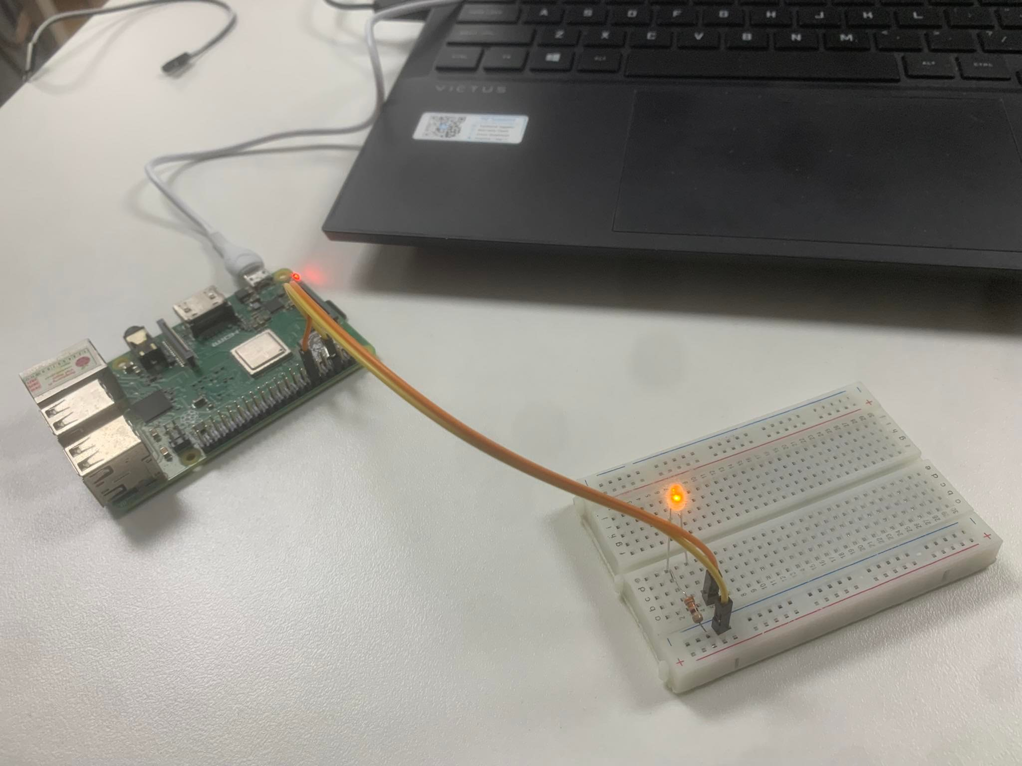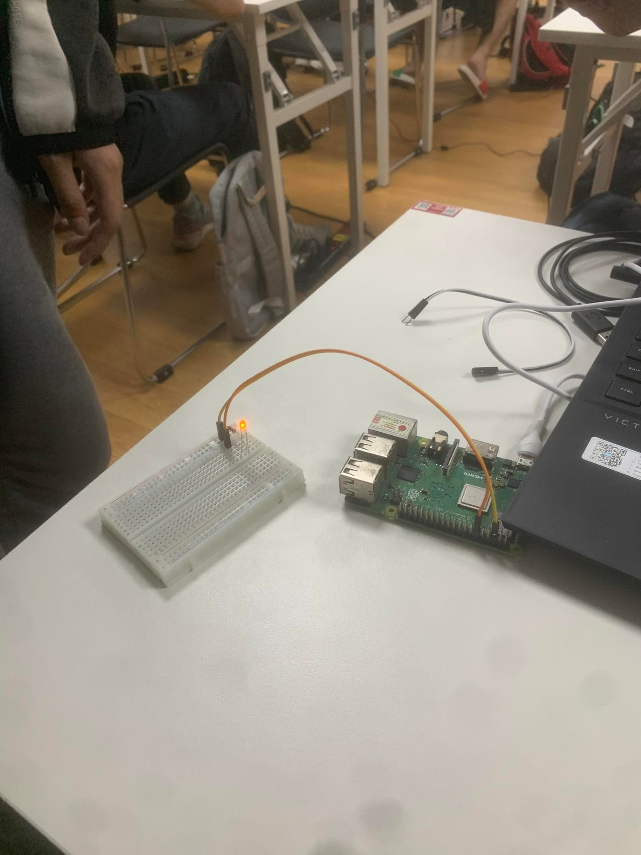

**20. If you are comfortable in your understanding of the GPIO registers then you should be   
able to answer the following questions:**

20.1. What number bit is set (within the associated 32-bit block) to enable GPIO23 for   
writing: #9

20.2. What is the byte offset from GPIO_BASE that this 32-bit block must be written to in memory: #8

20.3. What number bit is set to set GPIO23 to ON (again within the 32-bit block associated with that GPIO pin): #28

20.4. What is the byte offset from GPIO_BASE that this 32-bit block must be written to   
memory: 200000

**22. Consider how you would program one of the GPIO pins used above to turn off the LED it controls. Choose one of the LEDs to turn off and answer the following:**

22.1. Which exact snippet of code will need to change compared to turning the LED on ?

mov r1, #1

lsl r1, #23

str r1, [r0, #28]

22.2. Provide the alternative code to turn the LED off (again you will need to refer to the   
GPIO register diagram).

mov r1, #1

lsl r1, #23

str r1, [r0, #40]